Setting/Resetting Text Giving

- In the RLC webpage click on the online giving and donations to ministry button
- Enter your email and password. This should take you to the I want to give page.
- If you receive an error message, click on create an account.
- You will need to create an account to give online and/or reconnect your giving information to your text giving. It is perfectly fine to use the same password you used to log onto the church website if that is convenient for you.
- Once you have created an account the site will take to the I want to give page.
- On the I want to give page you will need to set up a payment source.
- To set up your payment source (bank ACH, Credit Card, Bank Draft, ect.) give $1.00, select a giving category, give once, enter your payment source, and click the charge amount button.
- If you are selecting ACH this choice may take up to 2 days for the approval to clear the bank.
- You now can set up your text giving, log into the online giving and go to the I want to give page.
- Enter the amount you want to give, click on the wheel next to choose a payment source. 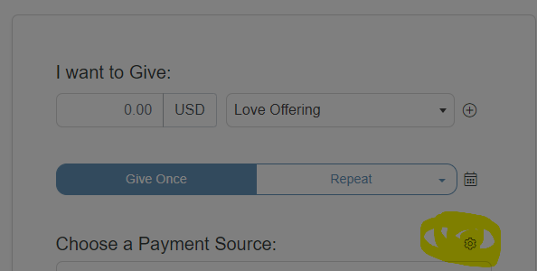This will take you to text giving setup to link you phone number to your payment source.
- Once you have linked you phone number you will receive a validation code to enter into the system to verify you.
- Once the code has been verified you are ready to give by text.
- To give by text you will need to text the word GIVE, followed by the amount you want to give.
- Once the text has been sent you will receive a reply to confirm the amount given, once it is confirmed with a yes or no. You will receive a text message stating your charge was a successful.

